|  | 1. **To study basic Linux utility commands** |
| --- | --- |

| **Name of Student** | **Hardik Prajapati** | **Roll No.** | **9152** |
| --- | --- | --- | --- |
| **Sign here to indicate that you have read all relevant material provided /available on Moodle while performing and writing this experiment** | | **Sign:** | |

**Late Submission Details (if any)**

| **Reason(s) of late submission** | **Date of practical performance** | **Date of practical submission** |
| --- | --- | --- |
|  |  |  |

**References used**

| 1 | Name and author of reference book(s) with page nos. |  |
| --- | --- | --- |
| 2 | Name and roll nos. of the peers whose help you have taken (if any) |  |

| **Rubrics for assessment of Experiment:**   | Indicator | Poor | Average | Good | | --- | --- | --- | --- | | Timeliness  Maintains Experiment deadline (3) | Experiment not done (0) | One or More than One week late (1-2) | Maintains deadline (3) | | Completeness and neatness  Complete all parts of Experiment (3) | N/A | < 80% complete (1-2) | 100% complete (3) | | Originality  Extent of plagiarism (2) | Copied it from someone else (0) | At least try to implement but could not succeed (1) | Implemented (2) | | Knowledge  In depth knowledge of the Experiment (2) | Unable to answer any questions (0) | Unable to answer few questions (1) | Able to answer all questions (2) | |
| --- | --- | --- | --- | --- | --- | --- | --- | --- | --- | --- | --- | --- | --- | --- | --- | --- | --- | --- | --- | --- |
| **Assessment Marks:**   | Timeliness |  | | --- | --- | | Completeness and neatness |  | | Originality |  | | Knowledge |  | | Total |  | |

**Signature of Teacher with date**

| **1.** | **Course, Subject & Experiment Details** |
| --- | --- |

| **Course & Branch** | **T.E. (ECS)** | **Estimated Time** | **02 Hours Per Week** |
| --- | --- | --- | --- |
| **Current Semester** | **Semester VI** | **Subject Name** | **Linux Server Administration** |
| **Chapter No. & Unit** | **2.1** | **Chapter Title** | **Basic System administration tasks** |
| **Experiment Type** | **Software Performance** | **Subject Code** | **ECL 604** |

| **2.** | **Aim & Objective of Experiment** |
| --- | --- |

1. To study basic Linux commands

| **3.** | **Expected Outcome of Experiment** |
| --- | --- |

1. To understand basic Linux commands for system administration

| **4.** | **Brief Description of the experiment** |
| --- | --- |

**Unix Commands to explore:**

cd, cp, ls, mv, rm, mkdir, rmdir, man, who, cat, echo, more, date, time, kill, history, chmod, passwd, who am i, who, time, bc, history, clear, man, lost, finger, pwd, cal, logout, shutdown

Also choose 5 additional Unix commands by your own

| 1. Execute the above-mentioned commands.  (For each command, document information in following manner)   | Command: | Description: | | --- | --- | | Options: | Description(s): | | Output | Observation | |
| --- | --- | --- | --- | --- | --- | --- |

| 1. Execute the above-mentioned commands.  (For each command, document information in following manner)   | Command:  cal | Description: displays calander | | --- | --- | | Options: | Description(s): | | Output- | Observation | |
| --- | --- | --- | --- | --- | --- | --- |

| 1. Execute the above-mentioned commands.  (For each command, document information in following manner)   | Command:  time | Description: shows current time | | --- | --- | | Options: | Description(s): | | Output | Observation | |
| --- | --- | --- | --- | --- | --- | --- |

| 1. Execute the above-mentioned commands.  (For each command, document information in following manner)   | Command:  whoami | Description: shows the current logged in user | | --- | --- | | Options: | Description(s): | | Output | Observation | |
| --- | --- | --- | --- | --- | --- | --- |

| 1. Execute the above-mentioned commands.  (For each command, document information in following manner)   | Command:  date | Description: date current date | | --- | --- | | Options: | Description(s): | | Output | Observation | |
| --- | --- | --- | --- | --- | --- | --- |

| 1. Execute the above-mentioned commands.  (For each command, document information in following manner)   | Command:  cd | Description:chages the current directory | | --- | --- | | Options: | Description(s): | | Output | Observation | |
| --- | --- | --- | --- | --- | --- | --- |

| 1. Execute the above-mentioned commands.  (For each command, document information in following manner)   | Command:  chmod | Description:changes the permissions of particular file | | --- | --- | | Options: | Description(s): | | Output | Observation | |
| --- | --- | --- | --- | --- | --- | --- |

| 1. Execute the above-mentioned commands.  (For each command, document information in following manner)   | Command:  mkdir | Description:makes new directory | | --- | --- | | Options: | Description(s): | | Output | Observation | |
| --- | --- | --- | --- | --- | --- | --- |

| 1. Execute the above-mentioned commands.  (For each command, document information in following manner)   | Command:  pwd | Description: tells present working directory | | --- | --- | | Options: | Description(s): | | Output | Observation | |
| --- | --- | --- | --- | --- | --- | --- |

| 1. Execute the above-mentioned commands.  (For each command, document information in following manner)   | Command:  cat | Description: reads the content of file and gives output of the same | | --- | --- | | Options: we can use “>” for creating the file if does not exist | Description(s): | | Output | Observation | |
| --- | --- | --- | --- | --- | --- | --- |

| 1. Execute the above-mentioned commands.  (For each command, document information in following manner)   | Command:  echo | Description: print the following output | | --- | --- | | Options: | Description(s): | | Output | Observation | |
| --- | --- | --- | --- | --- | --- | --- |

| **5.** | **Conclusions & Inferences** |
| --- | --- |

| **6.** | **Post Lab exercise** |
| --- | --- |

1. Create a text file in a directory of your roll no. Save the file with name “abc_rollno.txt”. Write a Unix command to get the location of above file from your home directory.

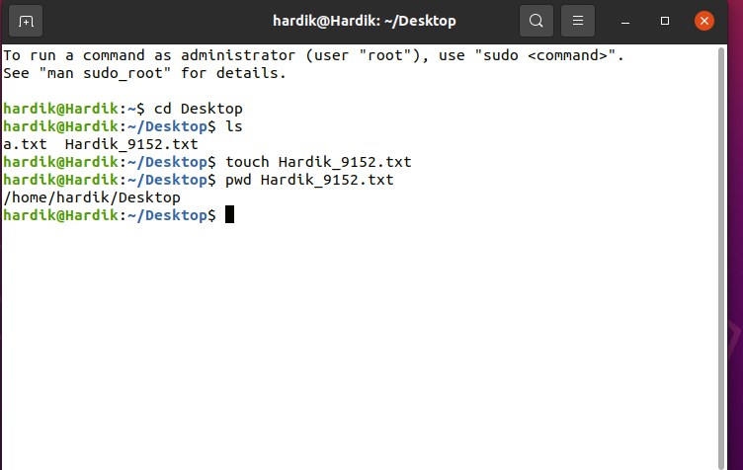

1. Using Unix command, show how to search a string pattern in above file.

